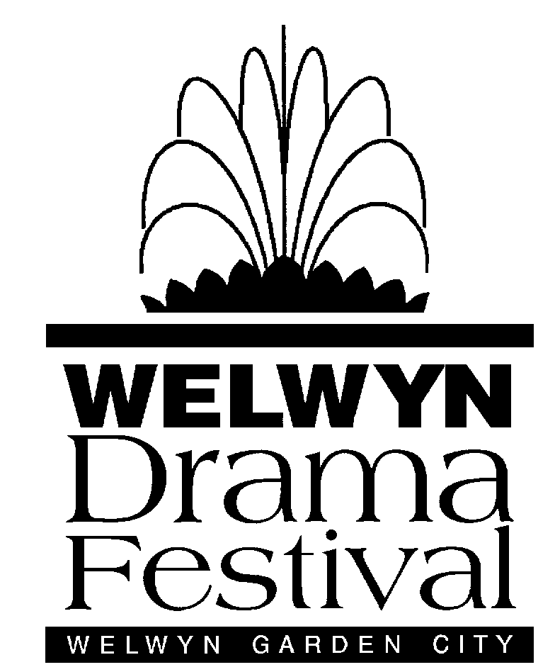
85th Welwyn Drama Festival
13th – 18th May 2019
Barn Theatre, Welwyn Garden City
Entry Form
Important: Please read the Rules before completing this form.
Your entry must be accompanied by the script.

Company or Team name in full
Play Title
Author

Is the play eligible for the New Play Prize? (please refer to the Rules) | YES / NO
Approximate running time
(must be between 20 min and 55 min)
Are there any dates on which it would be impossible for you to perform?

Director / Team Contact
e-mail (our preferred method of communication)
Postal Address (required)
Telephone (required)
I have read, and agree to abide by, the Rules of the Welwyn Drama Festival
I give my consent for my contact details to be kept on file by Welwyn Drama Festival.
I understand that I may be contacted by any of the organising committee before, during or after the festival. My details will not be passed to a third party without my consent.
Signed:………………………………………………………………
Please send your completed form, together with a printed copy of the script, to:
Welwyn Drama Festival, 89 Oakdale, Welwyn Garden City, Hertfordshire AL8 7QP
If you have any questions, please contact us: secretary@welwyndramafestival.com

